Hidden layers = 10

Learning rate = 0.3

Momentum = 0.2

Epochs = 500

Validation threshold = 20

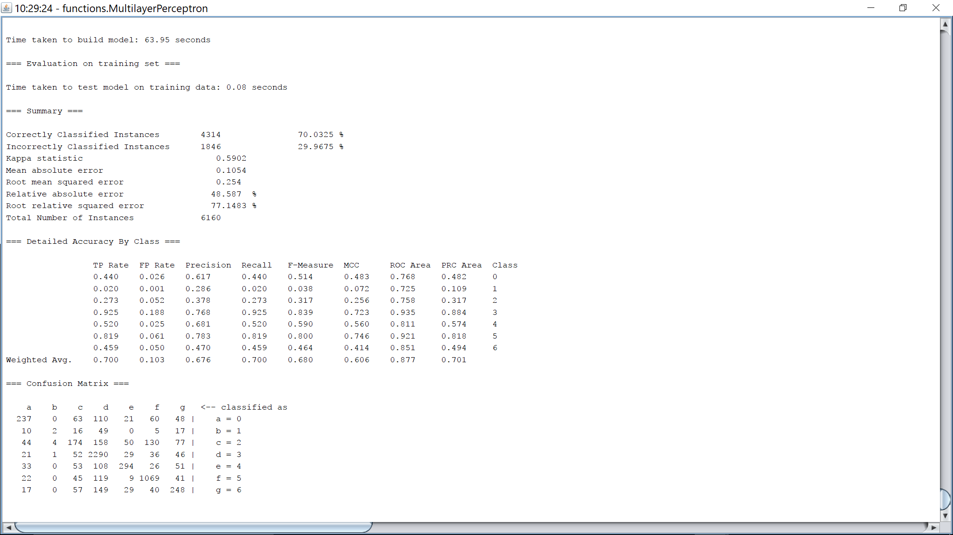

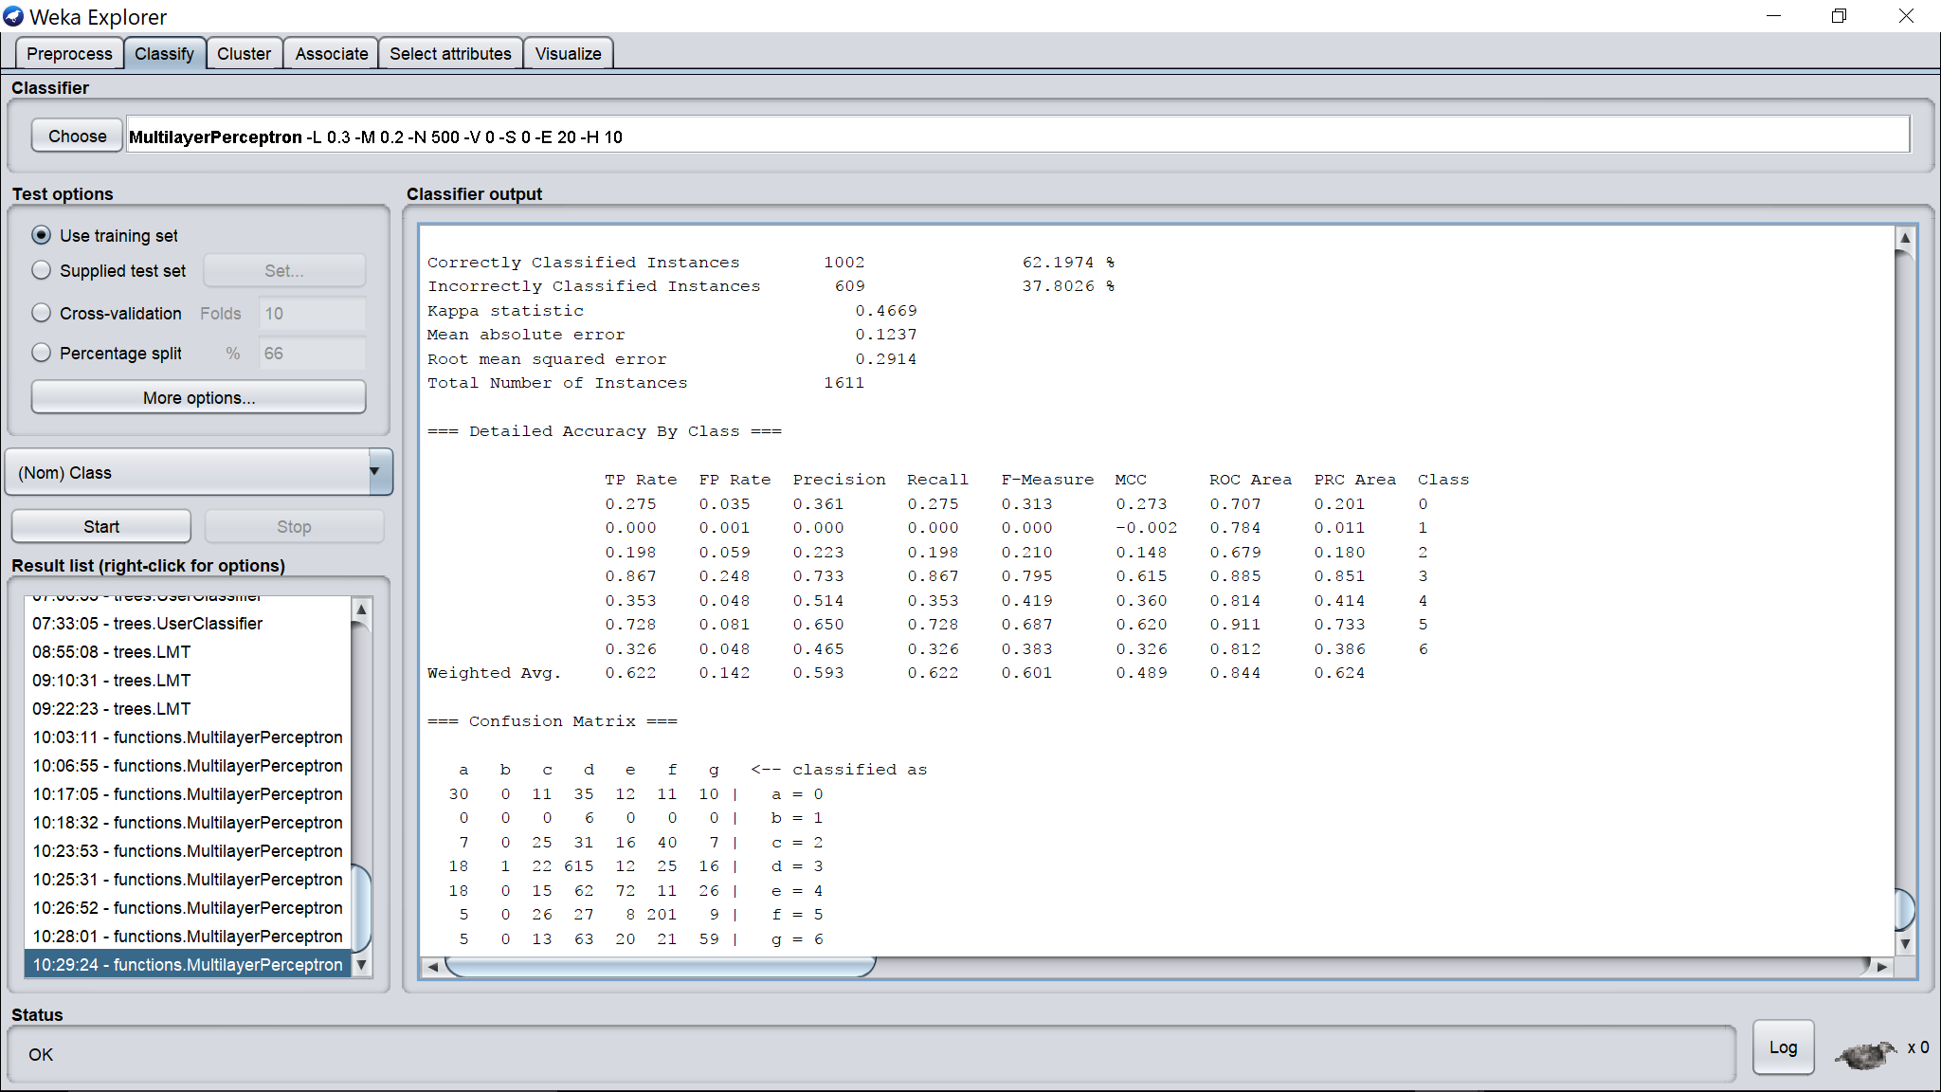

Hidden layers = 10

Learning rate = 0.3

Momentum = 0.2

Epochs = 500

Validation threshold = 1

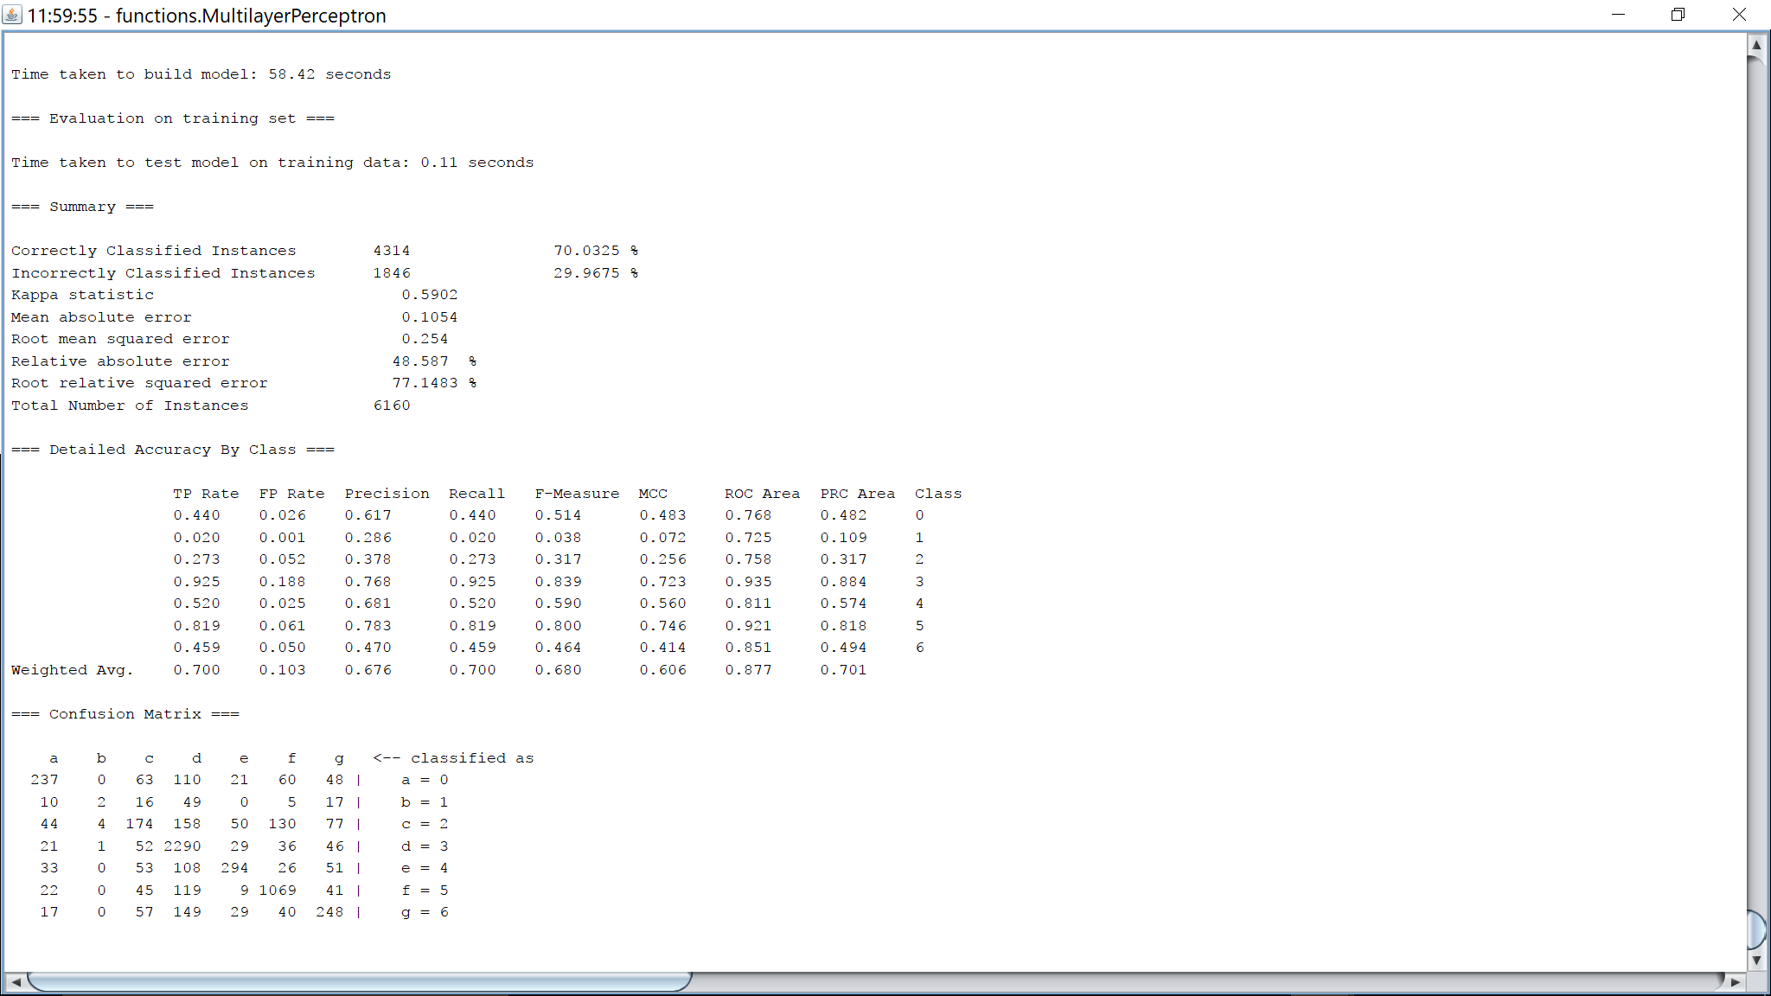

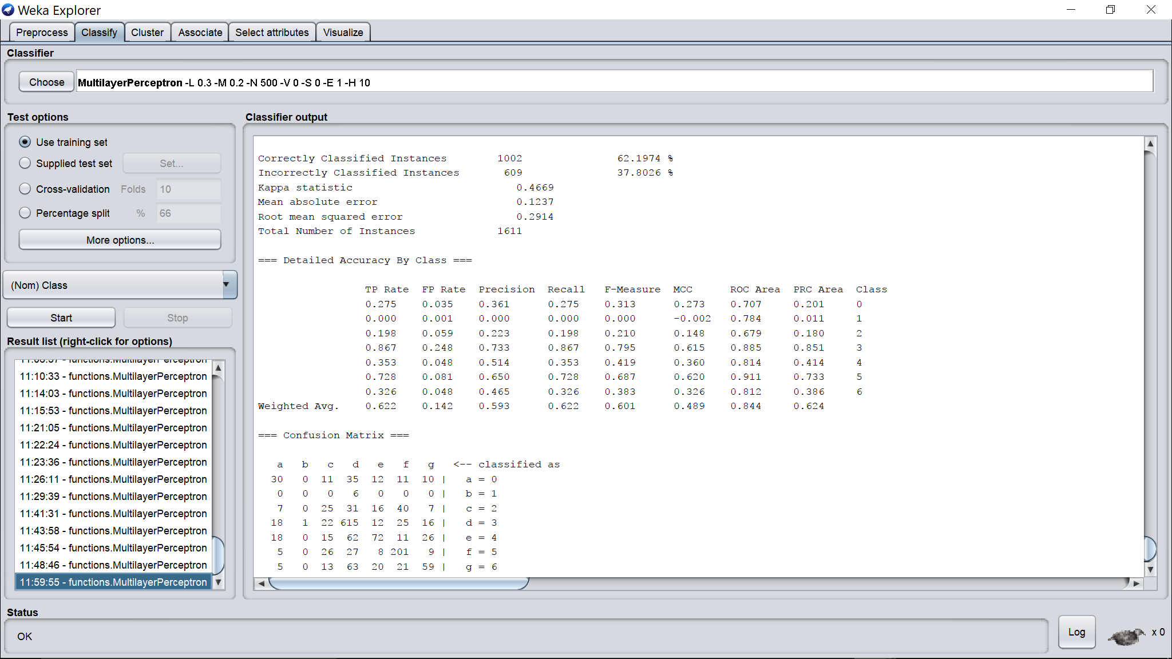

Hidden layers = 10

Learning rate = 0.3

Momentum = 0.2

Epochs = 500

Validation threshold = 2

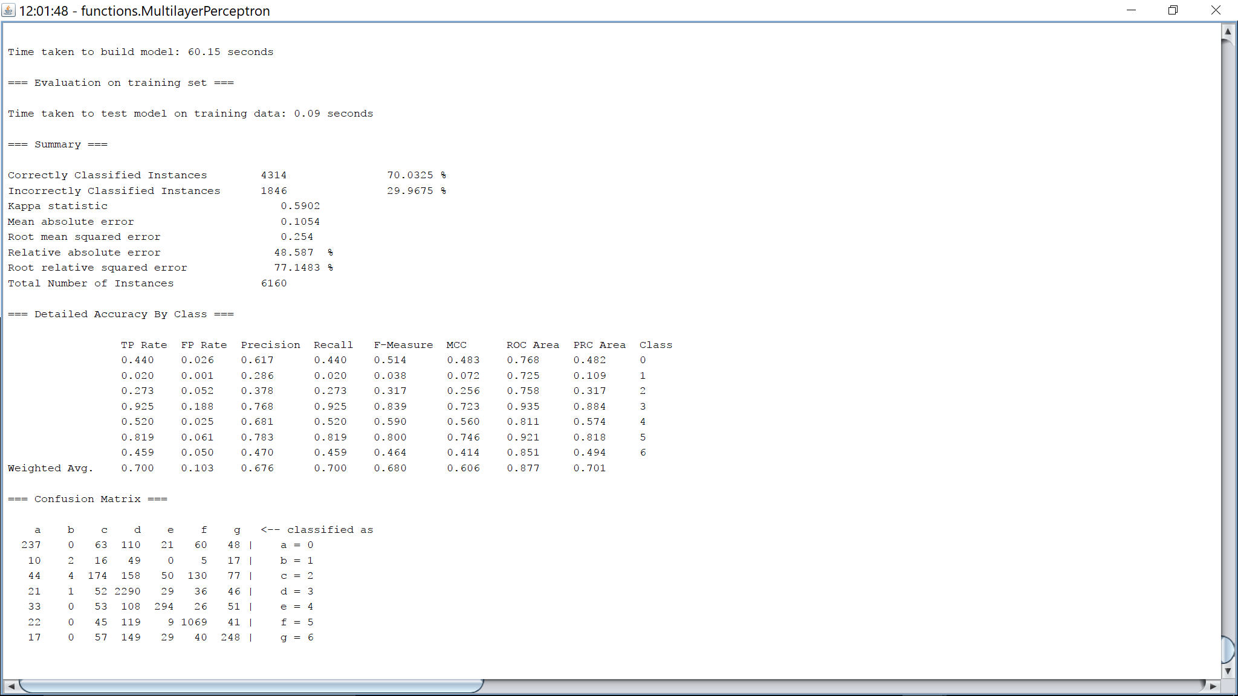

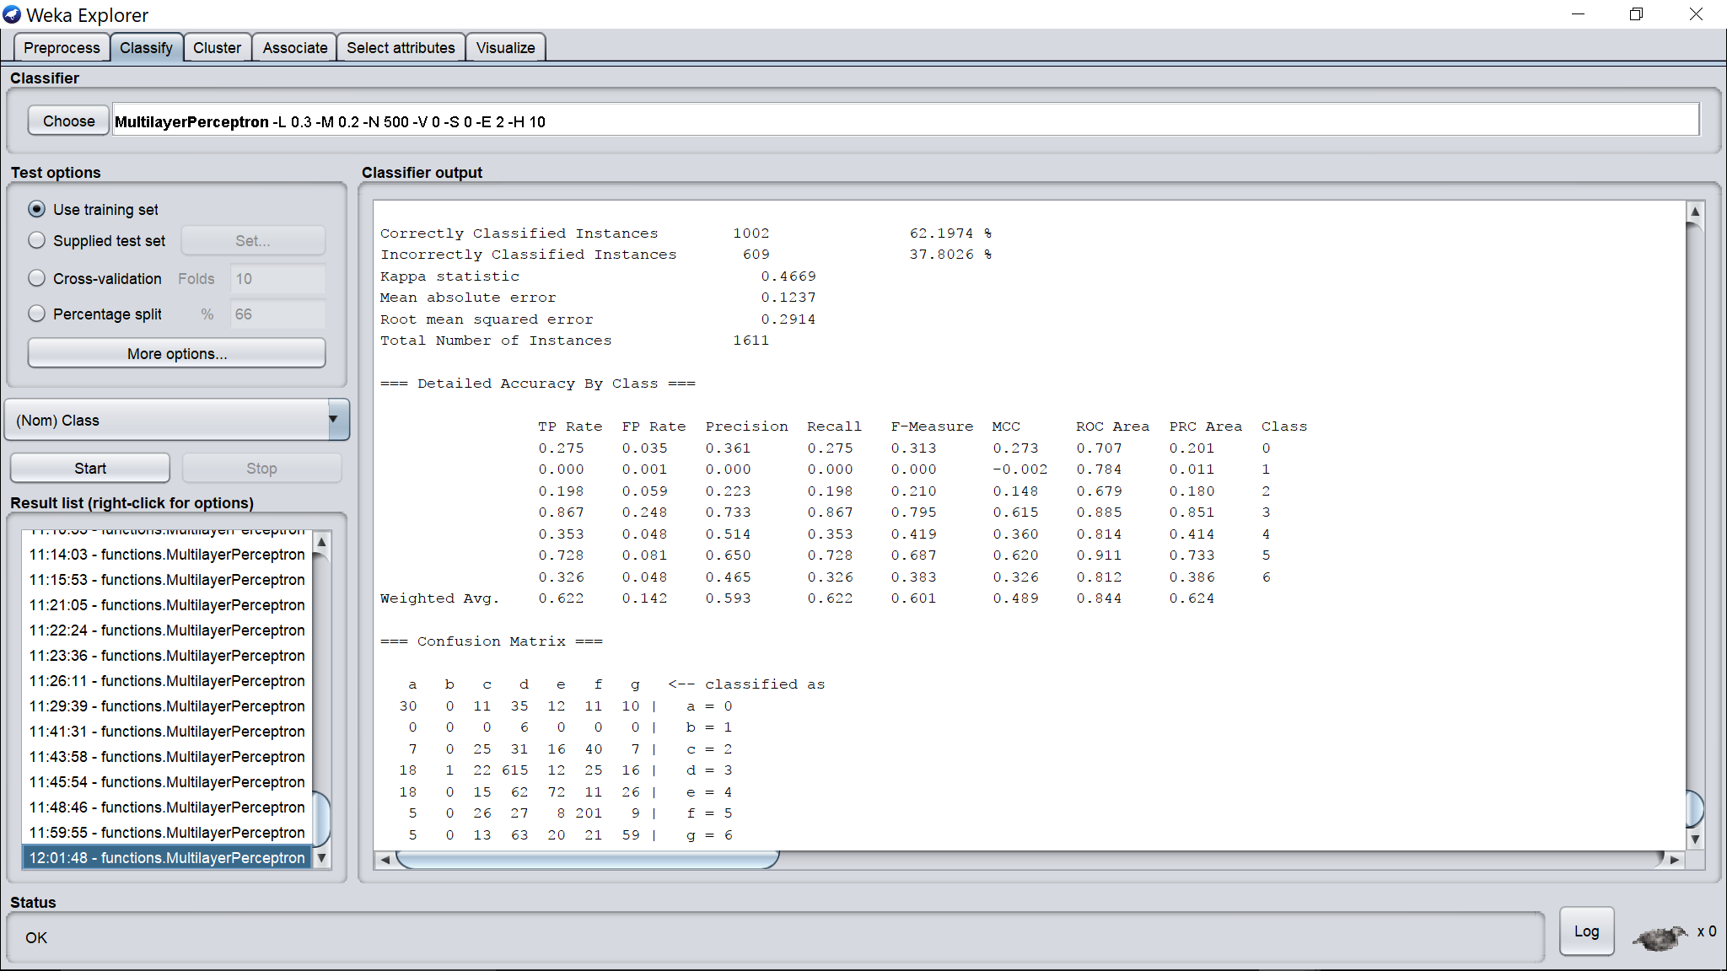

Hidden layers = 10

Learning rate = 0.3

Momentum = 0.2

Epochs = 500

Validation threshold = 5

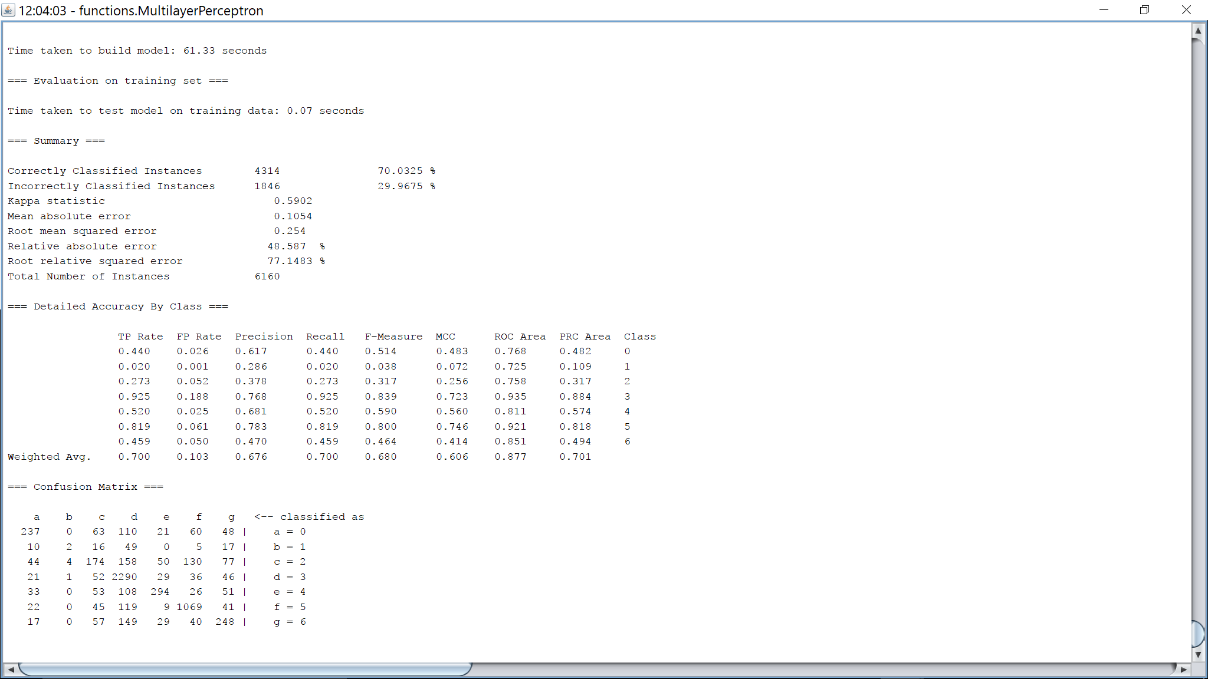

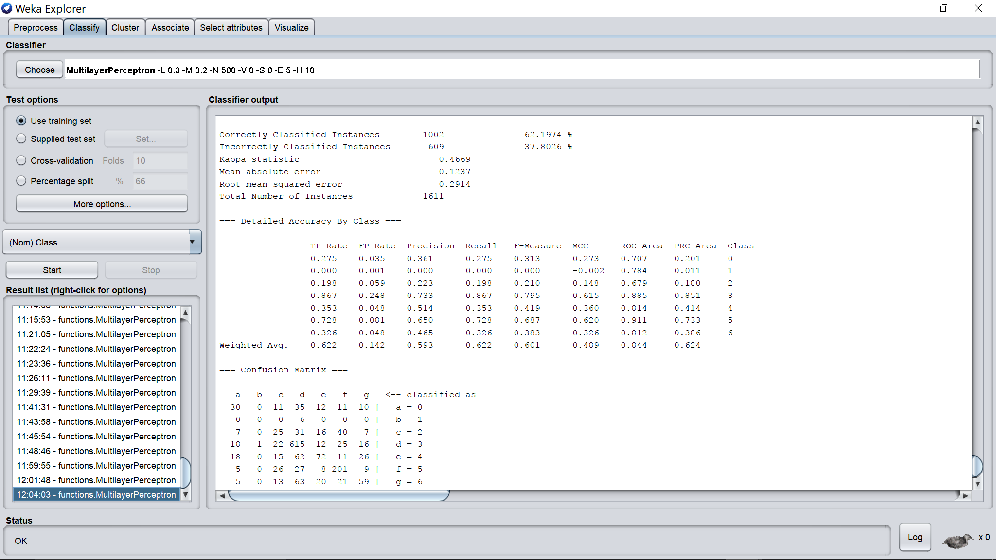

Hidden layers = 10

Learning rate = 0.3

Momentum = 0.2

Epochs = 500

Validation threshold = 10

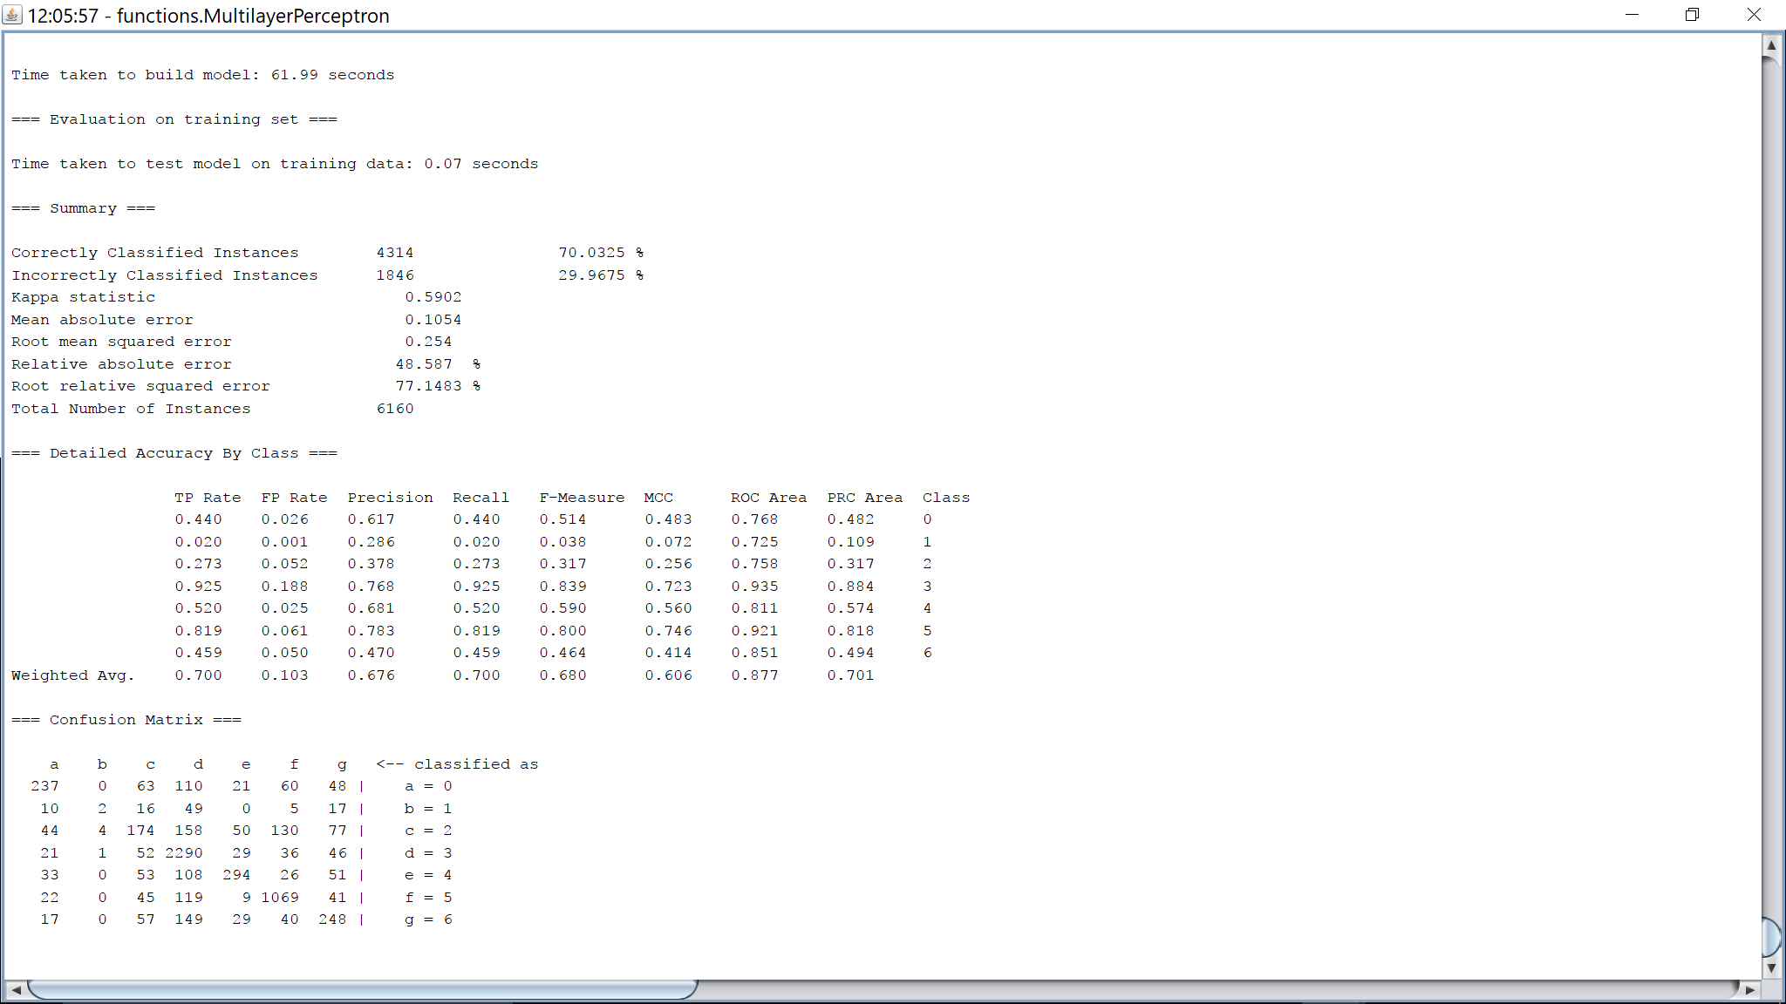

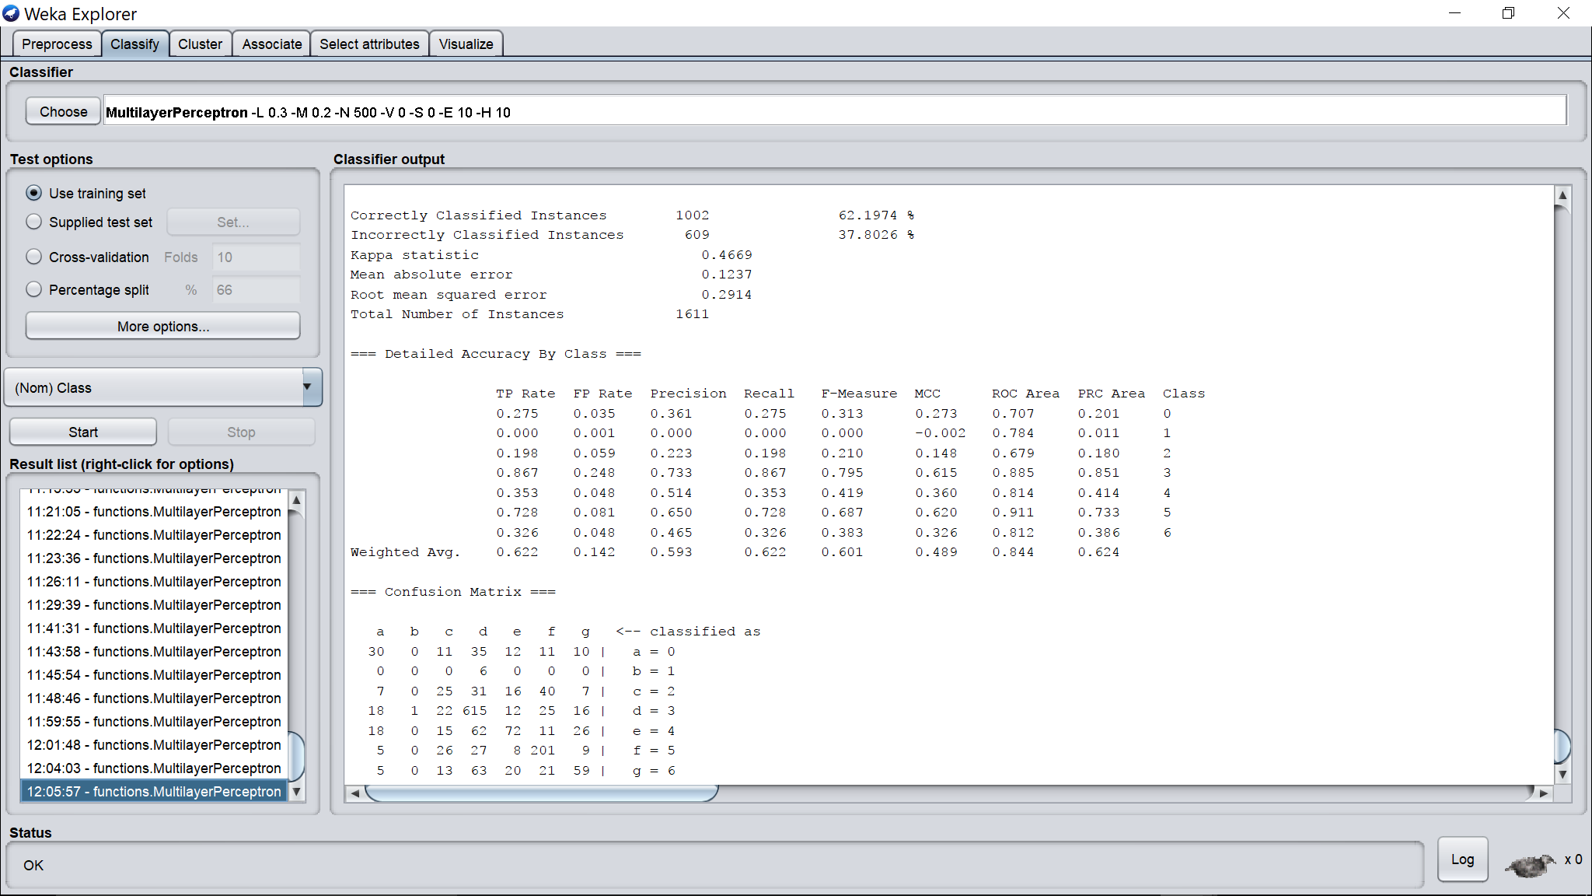

Hidden layers = 10

Learning rate = 0.3

Momentum = 0.2

Epochs = 500

Validation threshold = 50

